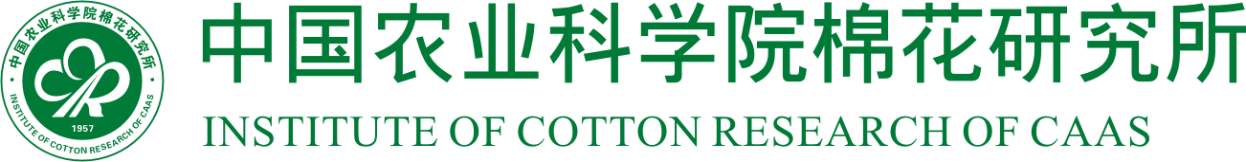

455000 中国河南省安阳市文峰区黄河大道38号 No.38, Huanghe Dadao, Wenfeng District, Anyang City, Henan Prov. 455000, China
Tel: 86-(0)372-2562200 Fax: 86-(0)372-2562256 E-mail: mianhuasuo@caas.cn http://www.cricaas.com.cn

Dear George-Jaeggli Barbara，

It is my pleasure to invite you to visit our institute (Institute of Cotton Research of CAAS ) in Anyang from October 23 to 29 this year. We are very interested in your research on photosynthetic physiology and high-throughput phenotype of plants，and expect a further communication between us to discuss scientific cooperation on cotton research.

All the costs occurred in this trip will be paid by our institute. I hope this visit will be a fruitful cooperation between us, and please let us know if we can be of any further assistance to you in the arrangements for your mission in China.

We look forward to seeing you soon.

Prof. Fuguang Li
Director General
Institute of Cotton Research, Chinese Academy of Agricultural Sciences
No.38 Huanghe Road, Anyang, Henan, China, 455000

